

Summer Internship Report

on
“TITLE OF SUMMER INTERNSHIP”

CS376SI

Submitted by

Risheek S
1RV22c160

Submitted in

partial fulfillment for the award of degree

of

BACHELOR OF ENGINEERING

in

DEPARTMENT OF

COMPUTER SCIENCE AND ENGINEERING

2025-26
RV COLLEGE OF ENGINEERING®
(Autonomous Institution Affiliated to Visvesvaraya Technological University, Belagavi)

Department of COMPUTER SCIENCE AND ENGINEERING
Bengaluru– 560059



CERTIFICATE

Certified that the Internship work titled “Video Wall Application” carried out by Risheek S, USN: 1RV22CS160, a Bonafide student, submitted in partial fulfilment for the award of Bachelor of Engineering in Computer Science and Engineering of RV College of Engineering®, Bengaluru, affiliated to Visvesvaraya Technological University, Belagavi, during the year 2025-26. It is certified that all corrections/suggestions indicated for internal assessment have been incorporated in the report deposited in the departmental library. The Internship report has been approved as it satisfies the academic requirement in respect of internship work prescribed for the said degree.

Evaluation Committee Member/s  (Name, Signature)  1.  2. | NAME  Professor and Head  Department of CSE  RV Collège of Engineering

Name of the External Examiners Signature with Date

1.____________________ __________________

2.____________________ __________________

CERTIFICATE FROM ORGANIZATION from where the Internship was carried out

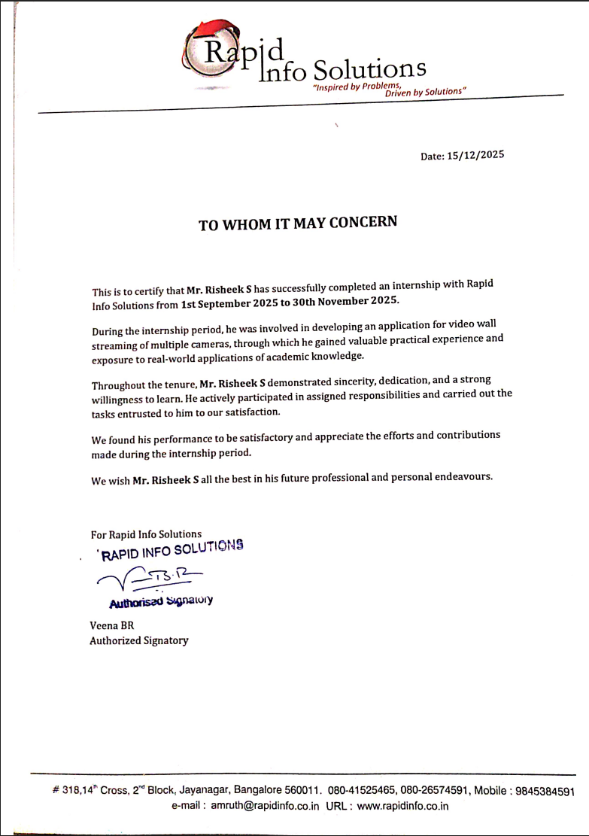

(i)

ACKNOWLEDGEMENT

I express my sincere gratitude to Rapid Info Soltuions for providing me the opportunity to undergo my internship and gain practical exposure to real-world engineering problems.

I would like to thank Umashankar J, System Architect, for his continuous guidance, encouragement, and valuable technical insights throughout the internship.

I also thank Dr. Azra Nasreen, RV College of Engineering, for academic support and motivation. Finally, I am grateful to my family and friends for their constant support.

Risheek S
1RV22CS160

(ii)

Executive Summary

This internship report presents the work carried out during my internship at [Organization Name], where I was actively involved in the design and implementation of a Video Wall System capable of handling multiple live video streams in real time. The primary objective of the project was to develop a scalable and efficient solution for simultaneously displaying and managing multiple video feeds for surveillance and monitoring applications.

The project focused on ingesting RTSP-based video streams from various sources, processing them using the GStreamer multimedia framework, and rendering them concurrently in a grid-based layout. Special attention was given to ensuring smooth playback, low latency, and synchronization across streams. The system was designed to be modular, allowing dynamic addition or removal of video feeds without disrupting the overall pipeline.

A significant portion of the work involved performance optimization and memory management. Challenges such as increasing memory usage, pipeline instability, and corrupted recordings were identified and resolved through systematic debugging and analysis of caps negotiation, buffer handling, and muxer configurations. Recording functionality was implemented using stream segmentation techniques to enable reliable storage of video data for later review.

In addition to technical implementation, the internship provided exposure to real-world software development practices, including requirement analysis, iterative development, testing, and documentation. The project required close collaboration with mentors and team members, enhancing problem-solving abilities and professional communication skills.

Through this internship, I gained hands-on experience in multimedia systems, real-time video streaming, Linux-based development, and system-level debugging. The knowledge and skills acquired during this period have strengthened my understanding of large-scale video processing systems and prepared me for advanced work in multimedia and system software engineering.

(iii)
Table of Contents

Certificate from Industry/Organization |  | (i)
Acknowledgement |  | (ii)
Executive Summary |  | (iii)
List of Figures |  | (iv)
List of Tables |  | (vi)
Chapter 1
Profile of the Organization
1.1 | Organizational Structure | 1
1.2 | Products | 2
1.3 | Services | 3
1.4 | Business Partners | 4
1.5 | Financials | 5
1.6 | Manpower | 6
1.7 | Societal Concerns | 7
1.8 | Professional Practices | 8
Chapter 2
Activities of the Department
Chapter 3
Tasks Performed
3.1 | Summary of the tasks performed during
Chapter 4
Reflections
4.1 | Technical Knowledge acquired
4.2 | Soft skills acquired
References and Annexures

(iv)

Chapter 1 – Profile of the Organization

1.1 Organizational Structure
Rapid Info Solutions follows a structured hierarchy comprising management, engineering, research and development, quality assurance, and operations teams. The internship was carried out under the Dev Team which focuses on system software and multimedia solutions.

1.2 Products
The organization develops solutions in areas such as:
- Video surveillance systems
- Real-time streaming platforms
- Embedded and system-level software
- Monitoring and visualization tools

1.3 Services
- Software development and consulting
- Multimedia and video analytics solutions
- System integration and deployment

1.4 Business Partners
The organization collaborates with technology vendors, system integrators, and enterprise clients for delivering end-to-end solutions.

Camera Providers (IP / Surveillance Cameras)
- Hikvision – Enterprise and city-scale IP surveillance cameras
- Dahua Technology – Network and AI-enabled security cameras
- Axis Communications – High-quality IP cameras for mission-critical systems
- Bosch – Industrial and professional surveillance solutions
- Hanwha Vision – Secure, enterprise-grade cameras
- CP Plus – Cost-effective cameras widely used in India
- Sony – High-performance imaging and camera sensors

Network Switch Providers (Surveillance & Video Streaming Networks)
- Cisco – Enterprise managed switches with PoE and QoS support
- Juniper Networks – High-throughput switching for large deployments
- HPE Aruba – Secure and scalable switching solutions
- Ubiquiti – Cost-effective managed switches for SMB environments
- Netgear – Smart and managed switches for mid-scale setups
- TP-Link – Affordable PoE switches for IP cameras
- D-Link – Layer 2/3 switches for enterprise surveillance networks

1.5 Financials
The organization follows sustainable financial practices with steady growth driven by software services and product innovation. (Exact figures are confidential.)

1.6 Manpower
The organization consists of skilled professionals including software engineers, system architects, QA engineers, and project managers.

- Senior Management – Responsible for strategic planning, business decisions, and organizational leadership.
- Project Managers – Oversee project planning, scheduling, coordination, and timely delivery of projects.
- System Architects – Design overall system architecture, technology stack, and integration strategies.
- Software Engineers – Develop, implement, and maintain application and system-level software solutions.
- Multimedia / Video Engineers – Handle video streaming, encoding, decoding, and pipeline optimization.
- Quality Assurance (QA) Engineers – Perform testing, validation, and quality control to ensure reliability and performance.
- DevOps / IT Support Team – Manage infrastructure, deployment, system monitoring, and maintenance.
- Technical Support Engineers – Provide post-deployment support and troubleshoot customer issues.

1.7 Societal Concerns
The company places strong emphasis on ethical business practices and ensures that all operations are conducted with integrity, transparency, and accountability. Ethical guidelines are strictly followed in areas such as data handling, customer engagement, and employee conduct. By adhering to established industry standards and regulatory frameworks, the organization ensures that its technologies are developed and deployed in a responsible manner, minimizing misuse and promoting trust among stakeholders.

In the domain of data security, the organization adopts robust measures to protect sensitive information generated by surveillance and monitoring systems. Secure network configurations, controlled access mechanisms, encryption techniques, and regular security audits are implemented to safeguard video data from unauthorized access or breaches. These practices are particularly critical in surveillance environments, where privacy and confidentiality are of utmost importance.

Furthermore, the company is committed to responsible technology development, ensuring that surveillance solutions are designed with consideration for societal impact and privacy concerns. The organization promotes compliance with legal and ethical norms while encouraging the use of technology for public safety, operational efficiency, and infrastructure monitoring. This balanced approach reflects the company’s commitment to leveraging advanced technologies while maintaining respect for individual rights and societal well-being.

1.8 Professional Practices
The organization follows Agile development methodologies to ensure flexibility, efficiency, and timely delivery of software projects. Development activities are carried out in iterative cycles, allowing continuous feedback, incremental improvements, and early identification of risks. Regular planning meetings, progress reviews, and task tracking help align technical efforts with project objectives and timelines.

Strong emphasis is placed on documentation standards throughout the project lifecycle. Technical design documents, requirement specifications, and user guides are maintained to ensure clarity, consistency, and knowledge transfer. Proper documentation enables maintainability, simplifies onboarding of new team members, and ensures continuity across development phases.

The organization strictly adheres to version control practices using centralized repositories. Source code is maintained in structured branches to support parallel development and controlled integration. Commit guidelines, meaningful commit messages, and branch management strategies help track changes efficiently and reduce integration conflicts.

Code review mechanisms are an integral part of the development process. Peer reviews are conducted to ensure code quality, adherence to coding standards, performance optimization, and security best practices. Feedback from reviews helps identify bugs early, improves readability, and promotes collective code ownership within the team.

Additionally, the organization follows systematic testing and quality assurance practices, including unit testing, integration testing, and regression testing. Issues identified during testing are tracked and resolved using structured issue-management workflows. These professional practices collectively contribute to the development of reliable, secure, and high-quality software systems.

– Activities of the Department

The Video Wall Development Team comprises a multidisciplinary development team responsible for the design, development, and deployment of the Video Wall solution. The team structure is organized to efficiently handle both system-level and application-level requirements of real-time surveillance systems.
- Project Manager
Oversees project planning, scheduling, resource allocation, and coordination between stakeholders to ensure timely delivery of the video wall solution.
- System Architect
Designs the overall system architecture, including multimedia pipeline design, network topology, and integration of video sources, display systems, and storage components.
- Multimedia / Video Processing Engineers
Develop and optimize multimedia pipelines using frameworks such as GStreamer. They are responsible for handling real-time video streaming, encoding and decoding, synchronization, and latency optimization.
- Backend / Systems Engineers
Implement core system logic, stream management, recording mechanisms, and performance monitoring. They ensure stability, scalability, and efficient resource utilization of the video wall system.
- Frontend / UI Engineers
Design and develop the user interface for the video wall, including grid layouts, stream controls, and monitoring dashboards suitable for control room environments.
- Quality Assurance (QA) Engineers
Perform functional, performance, and stress testing to validate system reliability under multiple concurrent video streams. They ensure compliance with quality and stability requirements.
- DevOps / Infrastructure Engineers
Manage deployment environments, system configuration, logging, and monitoring. They ensure high availability and smooth operation of the video wall application in production environments.
- Technical Support and Maintenance Team
Provide post-deployment support, troubleshoot operational issues, and assist in system upgrades and maintenance.

Chapter 3 – Tasks Performed

3.1 Summary of Tasks Performed During the Internship

- In-depth study of RTSP streaming protocols and video codecs
Conducted a comprehensive study of Real-Time Streaming Protocol (RTSP), focusing on session initiation, media negotiation, transport mechanisms, and stream control. Analyzed the behavior of live video feeds under varying network conditions and studied industry-standard video codecs such as H.264 and H.265 to understand compression efficiency, latency trade-offs, and bandwidth optimization in real-time surveillance systems.
- Design of a scalable multi-stream video wall architecture
Designed a modular and scalable video wall architecture capable of handling multiple concurrent live video streams. The design included components for stream ingestion, decoding, buffering, rendering, synchronization, and recording. Considerations were made for scalability, fault tolerance, and ease of integration with different camera vendors and network configurations.
- Development of GStreamer-based multimedia pipelines using Python
Implemented multimedia pipelines using GStreamer Python bindings to handle stream decoding, format negotiation, buffering, and display. The pipelines were designed to be dynamically configurable, enabling runtime control over stream parameters and ensuring robustness in long-running deployments.
- Implementation of grid-based video display using GTK framework
Developed a GTK-based graphical user interface to display multiple live video streams in a structured grid layout. The UI was optimized for control room environments, providing clear visibility, responsiveness, and efficient rendering of video content across multiple display tiles.
- Integration of hardware-accelerated video rendering
Integrated hardware-accelerated video sinks to leverage GPU-based decoding and rendering. This significantly reduced CPU utilization and ensured smooth playback of high-resolution streams, even under heavy multi-stream workloads.
- Implementation of video recording and stream segmentation mechanisms
Implemented reliable video recording using split-muxing techniques to segment video files based on time or size constraints. This approach ensured manageable file sizes, improved fault tolerance, and facilitated efficient archival and playback of recorded surveillance footage.
- Debugging of memory consumption and pipeline stability issues
Investigated and resolved issues related to gradual memory growth, caps negotiation failures, and pipeline instability. Analyzed buffer allocation patterns, element properties, and data flow behavior to ensure stable long-term operation of the video wall system.
- Performance optimization and system tuning
Optimized pipeline performance by tuning queue parameters, buffer sizes, and thread configurations. Conducted stress testing with multiple simultaneous video streams to evaluate system performance, latency, and resource utilization under realistic operational conditions.
- System-level debugging and monitoring
Used system monitoring tools and logging mechanisms to track CPU, memory, and GPU utilization. Identified bottlenecks and optimized system-level parameters to enhance overall performance and reliability.
- Comprehensive documentation of system design and implementation
Prepared detailed documentation covering system architecture, pipeline configurations, deployment steps, and troubleshooting procedures. This documentation serves as a reference for future enhancements, maintenance, and knowledge transfer within the organization.

Chapter 4 – Reflections

4.1 Technical Knowledge Acquired
- Real-time multimedia streaming concepts
Acquired a strong understanding of real-time multimedia streaming principles, including live stream acquisition, buffering strategies, latency management, and synchronization. Learned how network conditions such as bandwidth variation, packet loss, and jitter affect live video delivery, and how streaming systems are designed to maintain continuity and reliability in surveillance and monitoring environments.
- GStreamer framework and pipeline design
Gained hands-on experience with the GStreamer multimedia framework, focusing on pipeline architecture, element chaining, and data flow management. Learned to design modular and efficient pipelines for decoding, processing, and rendering video streams. Practical exposure included dynamic pipeline creation, caps negotiation, pad linking, and runtime debugging of complex multimedia workflows.
- RTSP, codecs, muxers, and sinks
Developed in-depth knowledge of RTSP-based streaming, including session control, stream negotiation, and transport protocols. Studied video codecs such as H.264 and H.265 with respect to compression efficiency, quality, and latency. Gained practical experience in configuring muxers for recording and sinks for display, ensuring compatibility, stability, and optimal performance of the end-to-end video pipeline.
- Linux system debugging and performance monitoring
Acquired practical skills in debugging multimedia applications on Linux systems. Learned to analyze CPU, memory, and GPU utilization, identify bottlenecks, and monitor long-running processes. Used logging, diagnostic tools, and systematic testing approaches to investigate memory growth, pipeline stalls, and performance degradation in real-time systems.
- Python-based system integration
Developed proficiency in integrating complex system components using Python. Learned to manage multimedia pipelines programmatically, handle asynchronous events, implement error handling, and coordinate interactions between the backend logic and the graphical user interface. This experience strengthened understanding of Python as a system integration and automation tool in large-scale multimedia applications.

4.2 Soft Skills Acquired
- Professional communication
Developed effective professional communication skills through regular interactions with mentors, team members, and supervisors. Learned to clearly articulate technical ideas, report progress, discuss challenges, and seek feedback in a structured and professional manner. Exposure to technical discussions, meetings, and review sessions improved both verbal and written communication skills essential in a professional work environment.
- Problem-solving and analytical thinking
Enhanced problem-solving abilities by working on real-world technical challenges such as performance bottlenecks, memory management issues, and system stability concerns. Learned to approach problems analytically by breaking complex issues into smaller components, identifying root causes, evaluating possible solutions, and implementing effective fixes. This experience strengthened logical reasoning and decision-making skills.
- Time management
Learned to manage time efficiently while balancing multiple tasks such as development, testing, debugging, and documentation. Gained experience in prioritizing work based on project deadlines and task criticality. Adhering to timelines and milestone-based planning improved productivity and ensured consistent progress throughout the internship period.
- Working in a team environment
Gained valuable experience working as part of a collaborative team. Learned to coordinate with team members across different roles, respect diverse viewpoints, and contribute effectively toward shared goals. Participation in collaborative problem-solving and code reviews reinforced the importance of teamwork, adaptability, and mutual support in achieving project success.
- Technical documentation and reporting
Developed skills in preparing clear and structured technical documentation, including system descriptions, workflow explanations, and task reports. Learned the importance of maintaining accurate documentation for knowledge sharing, future reference, and project continuity. This experience improved attention to detail and the ability to present technical work in a clear and professional manner.

References

- H. Schulzrinne et al., RFC 2326 – Real Time Streaming Protocol (RTSP), IETF, 1998.
– Official specification defining RTSP architecture, session control, and streaming mechanisms.
- J. F. Kurose and K. W. Ross, Computer Networking: A Top-Down Approach, Pearson Education.
– Chapters on multimedia networking covering streaming architectures, RTP/RTSP, and performance considerations.
- L. Peroni and S. Gorinsky, An End-to-End Pipeline Perspective on Video Streaming in Best-Effort Networks, ACM Computing Surveys, 2024.
– Research paper discussing complete video streaming pipeline architecture and performance trade-offs.
- Simo Sjögren, Real-Time Video Processing in GStreamer Pipelines, Master’s Thesis, Tampere University.
– Practical exploration of real-time multimedia processing using GStreamer.
- R. Jain, RTP, RTCP, and RTSP: Internet Protocols for Real-Time Multimedia, Lecture Notes.
– Detailed academic explanation of real-time multimedia transport and control protocols.
- GStreamer Documentation, Application Development Manual.
– Official documentation describing pipeline design, element interaction, caps negotiation, and debugging techniques.
- Mark Richards, Software Architecture Patterns, O’Reilly Media.
– Reference for designing scalable, modular, and maintainable software architectures.
- Ian Sommerville, Software Engineering, Pearson Education.
– Covers professional software development practices, documentation standards, and lifecycle models.
- IEEE Std 830 / ISO/IEC Documentation Standards.
– Guidelines for writing software requirement specifications and technical documentation.
- Linux Performance Tools Documentation, Performance Analysis and Monitoring.
– Reference material for system-level debugging, profiling, and performance optimization.

